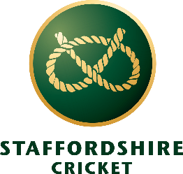
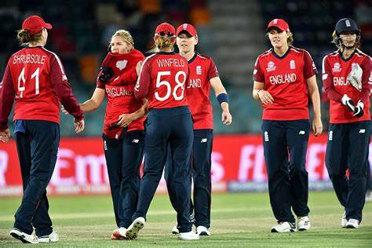
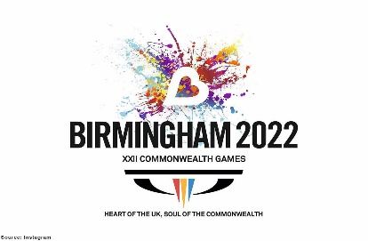
COMMONWEALTH GAMES 2022: CRICKET
Word Search

B | J | K | L | A | I | D | N | I | P | O | N | K | G | F | S | H
N | A | P | W | Q | C | R | I | C | K | E | T | Y | X | N | T | H
T | T | R | R | O | P | T | Y | F | O | N | H | P | I | L | R | E
W | I | O | B | N | Z | E | R | T | P | G | D | U | A | E | V | A
E | B | Z | X | A | M | J | K | I | O | L | H | E | S | D | U | I
N | I | P | K | S | D | A | M | P | U | A | W | I | O | G | F | L
T | F | A | F | P | K | O | Z | K | P | N | L | V | U | B | K | A
Y | D | K | T | S | J | S | S | J | O | D | P | B | T | A | L | R
T | I | I | U | D | G | D | T | M | N | K | O | T | H | S | P | T
W | U | S | P | E | R | E | M | Y | B | M | T | R | A | T | O | S
E | T | T | R | T | H | O | W | Z | A | T | E | E | F | O | E | U
N | C | A | S | Y | C | V | R | T | R | N | K | W | R | N | R | A
T | O | N | O | O | E | E | E | G | E | Z | C | Q | I | V | S | S
Y | W | I | C | K | I | R | T | F | W | S | I | S | C | B | D | D
N | E | W | Z | E | A | L | A | N | D | R | W | B | A | E | E | H
R | S | A | K | N | A | L | I | R | S | T | D | V | A | S | T | J
ENGLAND |  | AUSTRALIA |  | BARBADOS |  | CRICKET |  | WICKET
INDIA |  | NEW ZEALAND |  | SRI LANKA |  | COMMONWEALTH |  | OVER
PAKISTAN |  | SOUTH AFRICA |  | EDGBASTON |  | TWENTY TWENTY |  | HOWZAT

COMMONWEALTH GAMES 2022: CRICKET
Word Search Answers

B | J | K | L | A | I | D | N | I | P | O | N | K | G | F | S | H
N | A | P | W | Q | C | R | I | C | K | E | T | Y | X | N | T | H
T | T | R | R | O | P | T | Y | F | O | N | H | P | I | L | R | E
W | I | O | B | N | Z | E | R | T | P | G | D | U | A | E | V | A
E | B | Z | X | A | M | J | K | I | O | L | H | E | S | D | U | I
N | I | P | K | S | D | A | M | P | U | A | W | I | O | G | F | L
T | F | A | F | P | K | O | Z | K | P | N | L | V | U | B | K | A
Y | D | K | T | S | J | S | S | J | O | D | P | B | T | A | L | R
T | I | I | U | D | G | D | T | M | N | K | O | T | H | S | P | T
W | U | S | P | E | R | E | M | Y | B | M | T | R | A | T | O | S
E | T | T | R | T | H | O | W | Z | A | T | E | E | F | O | E | U
N | C | A | S | Y | C | V | R | T | R | N | K | W | R | N | R | A
T | O | N | O | O | E | E | E | G | E | Z | C | Q | I | V | S | S
Y | W | I | C | K | I | R | T | F | W | S | I | S | C | B | D | D
N | E | W | Z | E | A | L | A | N | D | R | W | B | A | E | E | H
R | S | A | K | N | A | L | I | R | S | T | D | V | A | S | T | J
ENGLAND |  | AUSTRALIA |  | BARBADOS |  | CRICKET |  | WICKET
INDIA |  | NEW ZEALAND |  | SRI LANKA |  | COMMONWEALTH |  | OVER
PAKISTAN |  | SOUTH AFRICA |  | EDGBASTON |  | TWENTY TWENTY |  | HOWZAT

