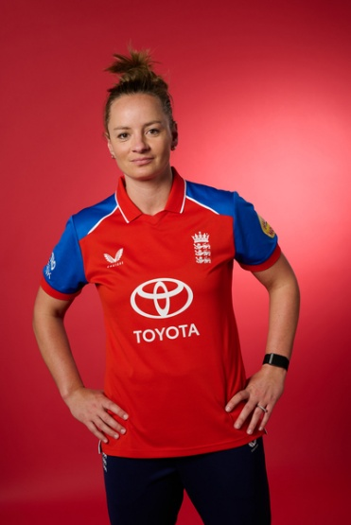
Danni Wyatt-Hodge
Current Role in Cricket
England, MI London, Surrey
When and how did you get involved in cricket at an early age?
I started playing at aged 8, joined Whitmore cricket club with my oldest brother Ryan, then got picked for Staffs u13s and scored 3 centuries in a row and got picked for Staffs seniors and then went from there.
Who had the most impact on you at the start of your career?
I owe a lot to Dave Ferris who was my 1-2-1 coach when I first got into the game, he had me in the squash courts working on basics which I still do now just not in the squash courts ha-ha! And I owe a lot to Andy Grice who would travel miles to come to Whitmore and throw at me whenever I needed during my times where I was getting a bit older and getting into England sides.
When / how were you involved in Staffordshire Cricket
From 2003 until 2012, playing through the age groups from under 13s until seniors. I was also at Staffs Cricket academy and then to Derby Academy so thank you to them! Alan Hill what a legend.
Most memorable moment from your time at Staffordshire Cricket
Playing for Staffs seniors as a 12-year-old not being able to get the ball off the square.

Best aspect of working in your role in cricket
I love being a part of a team and travelling the world with your mates and wanting to get better each day and keep improving and wanting to score runs for whoever I’m playing for.
Advice for a young person wanting to follow in your footsteps
Enjoy every moment playing with your teammates. Work hard and focus on yourself don’t worry what others are doing. Be hungry!

