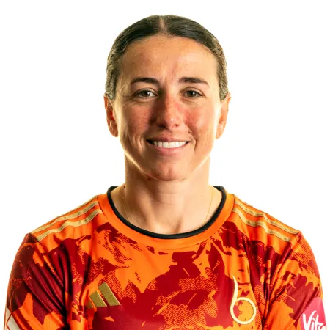
Georgia Elwiss
Current Role in Cricket
Professional cricketer at Blaze, Trent Rockets and ACT Meteors
When and how did you get involved in cricket at an early age?
Sport was in the family, my grandparents loved cricket and took me and my big brother to watch with them. We got hooked and it went from there.
Who had the most impact on you at the start of your career?
A couple of people really - Arthur Pickering at Wolverhampton, Leigh Rees at Staffordshire are the ones who spent the most time with me growing up but everyone who I crossed paths with would have inputted something into my game.
When / how were you involved in Staffordshire Cricket
I got selected for Staffordshire boys at u11 and then in the women’s and girls pathway a couple of years later. I progressed through their academy with Alan Hill and myself and Danni Wyatt-Hodge grew up there together.
Most memorable moment from your time at Staffordshire Cricket
Probably reaching the u15 and u17 finals with the girls.
I have really fond memories of playing with the boys at a young age but also going through the pathway and enjoying the challenge of playing and training with people better than me.

Impact Staffordshire Cricket had on you
It gave me my start in cricket and I wouldn’t be where I am now without the support of the coaches and people involved there. They would volunteer extra time to help out and it meant I could just turn up and train and enjoy it.
Best aspect of working in your role in cricket
The fact that it doesn’t feel like work at all.
Advice for a young person wanting to follow in your footsteps
Fall in love with the process and never stop having fun.

