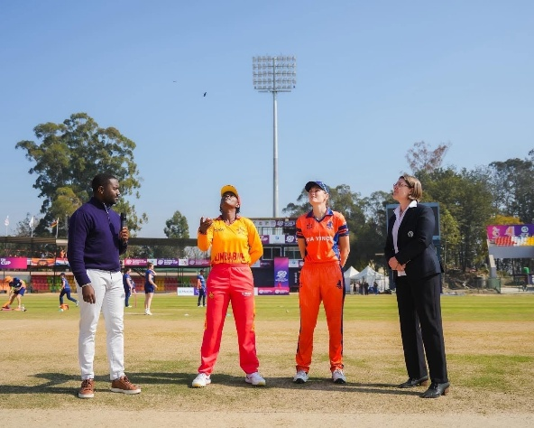
Helen Pack
Current Role in Cricket
Match Referee – ECB Professional Game and ICC International Panel

When and how did you get involved in cricket at an early age?
I started playing at school and a local PE teacher got me involved in a women’s club in Cheltenham (Hatherley and Reddings CC) when I was 15.

Who had the most impact on you at the start of your career?
I met Penny Thane at Loughborough University, and she encouraged me to go to the West Midlands trials – I also got involved in club cricket in Staffordshire playing for Wolverhampton, Fordhouses and Meir Heath.

When / how were you involved in Staffordshire Cricket
I was involved at the start of Staffordshire Women’s cricket when the West Midlands regional team was dissolved, and the new county system was established.

Most memorable moment from your time at Staffordshire Cricket
When we went on tour to Dublin and played several games against Irish teams and played at Trinity College.

Impact Staffordshire Cricket had on you
West Mids / Staffordshire cricket helped me to develop my skills and the offered the challenge of playing women’s cricket at the highest domestic level. I met some great people and made some great friends who I still connect with through my role as a Match Referee and socially.

Best aspect of working in your role in cricket
I have been given the opportunity to observe at first hand the growth of the women’s game at a professional level, seeing young talent coming through the system and seeing established players now have the opportunity to make a career from cricket – it is amazing to see the levels of performance now that players can commit to improving their game on a full time basis.

Advice for a young person wanting to follow in your footsteps
Get involved in as much cricket as possible, as a player, coach, umpire, spectator, any role really! Go on training courses and develop your understanding of the laws of the game and the playing regulations of the competitions you are involved in. Watch what the umpires do – look for subtle things they do which show them managing the game without imposing themselves on it.

