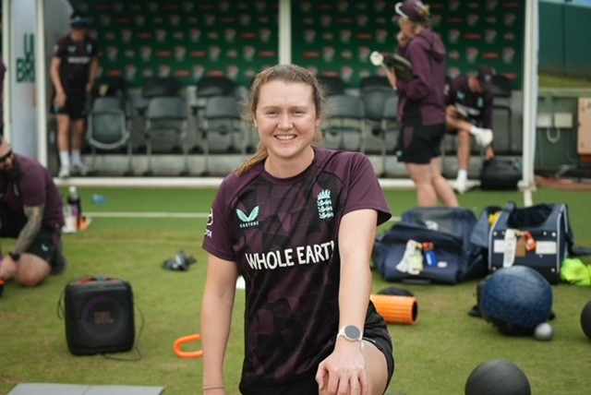
Grace Potts
Current Role in Cricket:
I am currently a professional cricketer for Lancashire County Cricket Club and have also played in The Hundred for the past 4 seasons. I have also been involved in the England performance programme this winter and have done numerous tours with England A.

When and How did I Get Into Cricket:
I got into cricket around 6 or 7 years old as my brother played and I used to get dragged along to all his club training sessions and so I started to join in and it kind of went from there.

Most Impact at The Start of My Career:
Leigh Rees was the one who first saw any potential in me and accepted me onto the county u11’s programme when I was 7 so I would say he kind of started the journey. Since then, there have been many people who had a big impact on me including lots of coaches from the Staffs age groups.

Most Memorable Staffs Moment:

We won the U17’s national semi final in a really tight game that we probably shouldn’t have won. But I remember that being a really exciting game and we were all buzzing to have got over the line. We were a close group at that time and so that was a very fun experience to win with your mates and all the parents on the side line.

Impact Staffs had on me:
Staffs started my journey really. I started with Staffs when I was 7 and worked my way through all the ages groups and to the women’s team. Staffs provided the platform for me to be noticed by what was then the regional set up and from there allowed me to become professional so in the career sense it gave me everything. From a personal sense it gave me so many friends and memories growing up that I absolutely love and wouldn’t change.

Best Aspect of My Role in Cricket:
I guess I can say that I get to do what I love for a living. To be able to play cricket full time is very special and something I don’t take for granted. It’s also been really nice over the last few years to be able to see the impact cricket is having on younger girls. To be in a position to hopefully be able to inspire young girls to start cricket is really rewarding.

Advice for Younger People:
Just give it a go and have fun. We all got into the game because we enjoyed it and you shouldn’t lose sight of that even if you want to take the game more seriously. So, I guess work hard but just enjoy the process and playing something you love with your mates.

